SPSS Basics

Using the Burnout.sav dataset as an example:

1. Data view
   1. You can tell which view you are in by looking at the bottom left of the screen. There are two tabs, one for data and one for variables. If you are entering numbers, you will want data view. If you want to work with the variable names/types, use variable view.
   2. Data view is what usually opens when you open a SPSS data file.
   3. All the buttons across the top are great – but I always forget what they do (except sort, I’ve got that one down), plus they are always changings with updates. I’ll give you the file menu versions on how to get to things. Please let me know if you find easier versions.
   4. Data entry “rules”:
      1. Each person is their own unique flower/individual, so they get their own ROW.
      2. Each variable should get its own COLUMN.
      3. These two rules will be true 99% of the time. That way you can tell easily what type of design it is (lots of columns? Repeated measures; only one DV but lots of value labels? Between subjects).
      4. You want to make almost everything a number. Want to label groups? Don’t use a string (it will often block you from doing certain stats). Use a number, and put a value label on top (see below).

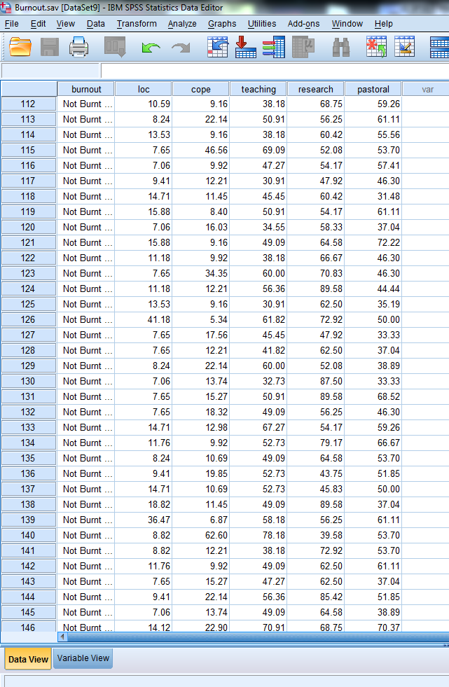

1. Variable View
   1. In this window you can change the variable name, type of variables, etc.
   2. Names – cannot have spaces or start with numbers.
   3. Type – numeric is the most common, but if you accidentally type some text in one of these columns, it automatically makes it a string. This screen is where you can change it.
   4. Width – how many characters you see (there may be more of them, but it will just hide them from you).
   5. Decimals – how many decimals you see
   6. Label – a place to include a more descriptive label. Some suggestions: short labels that make sense. Don’t use the whole question or write a lot. These labels are what you will see when you go to analyze the variables, so long labels are hard to read in those windows.
   7. Values – value labels let you assign text to numbers.
      1. 1 = Male,
      2. 2 = Female, etc.
      3. You can have as many as you like.
      4. If you don’t want to see the labels go to:
         1. View > value labels.
   8. Missing – lets you denote a specific number/word for missing data (like 9999). Suggestion: leave it blank (for reasons we’ll get to across the semester).
   9. Align – left, right, center.
   10. Measure – these are the scales from chapter 1. I usually just leave them all as scale because then they show up on all the different analyses. Sometimes you have to set them for specific analyses, but that’s pretty rare (IBM must know we are lazy).
   11. Role – I haven’t used this much, but you can change how the variable acts (but we can do this other ways that are a bit easier).

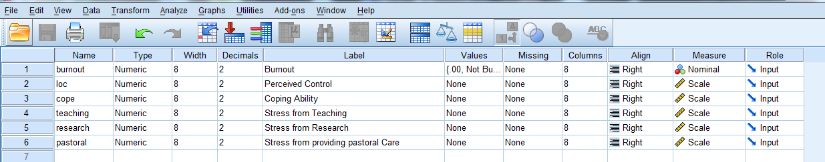

1. Frequency Charts and Histograms
   1. Analyze > Descriptives > Frequencies

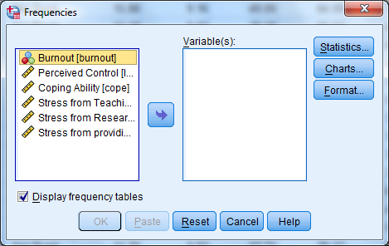

* 1. In SPSS, all variables are shown on the left, and then the variables you want to use are moved over to the right before you can do anything with them.
  2. For a frequency table, be sure to leave display frequency tables checked.
  3. Move over the variables you want to use.
  4. Hit statistics > you will get a lot of descriptive options. (My default ones I use are mean, standard deviation, and skew/kurtosis, but be sure to look at what the question is asking for).

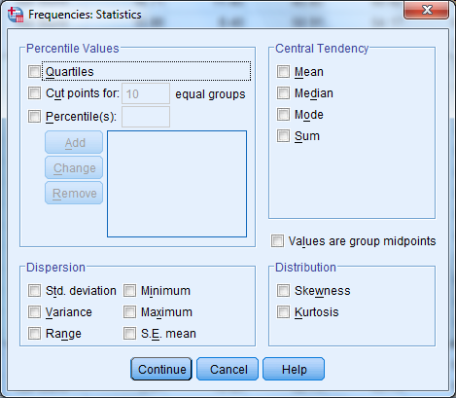

* 1. Hit charts: this window lets you get to the histograms (or pie charts, we are going to do different types of bar charts).
  2. I like to choose the normal curve option, helps me see if it’s skewed/kurtotic.

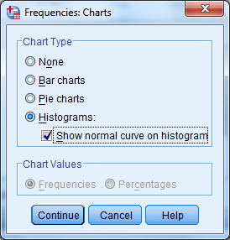

* 1. Hit ok.
  2. Output
     1. Statistics – gives you all the statistics options you asked for. Each variable gets its own column (the reverse is true for descriptives options see below).
     2. Frequency table – the frequencies of each value and percentages.
        1. Here’s where value labels are nice – instead of 1, 2 you see the value labels.
     3. Histograms – the bar chart of a frequency table. Not so useful for a nominal variable, fantastic for interval/ratio variables.

|  |  |  |  |  |  |  |  |
| --- | --- | --- | --- | --- | --- | --- | --- |
| **Statistics** | | | | | | | |
|  | | Burnout | Perceived Control | Coping Ability | Stress from Teaching | Stress from Research | Stress from providing pastoral Care |
| N | Valid | 467 | 467 | 467 | 467 | 467 | 467 |
| Missing | 0 | 0 | 0 | 0 | 0 | 0 |
| Mean | | .2548 | 17.9002 | 23.9191 | 55.4253 | 61.9067 | 55.2463 |
| Std. Deviation | | .43623 | 11.92856 | 15.72082 | 12.81964 | 14.73870 | 13.47594 |
| Skewness | | 1.129 | 2.230 | 1.465 | .527 | .005 | .306 |
| Std. Error of Skewness | | .113 | .113 | .113 | .113 | .113 | .113 |
| Kurtosis | | -.729 | 7.535 | 2.332 | .724 | -.405 | .179 |
| Std. Error of Kurtosis | | .225 | .225 | .225 | .225 | .225 | .225 |

|  |  |  |  |  |  |
| --- | --- | --- | --- | --- | --- |
| **Burnout** | | | | | |
|  | | Frequency | Percent | Valid Percent | Cumulative Percent |
| Valid | Not Burnt Out | 348 | 74.5 | 74.5 | 74.5 |
| Burnt Out | 119 | 25.5 | 25.5 | 100.0 |
| Total | 467 | 100.0 | 100.0 |  |

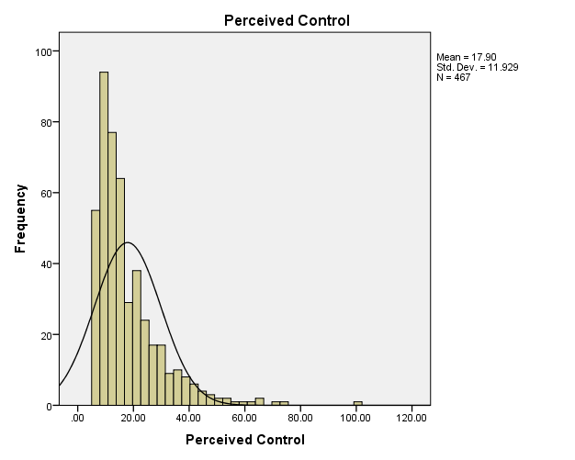

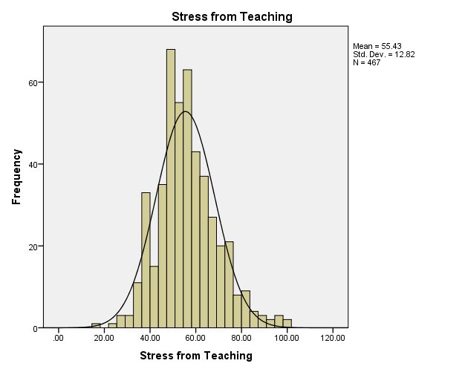

1. Descriptives (Z-scores)
   1. Analyze > Descriptives > Descriptives
   2. Again, left variables, right variables you are using.
   3. Save standardized values as variables = create z scores for that column, based on a column mean and standard deviation.
   4. Options – basic descriptives – notice that you cannot do quartiles or mode/median in this screen (so that’s why I usually only use it for z-scores, frequencies gives you more options and pretty charts).
   5. Output – box of descriptives that you asked for, but now the variables are rows (just to keep you on your toes).

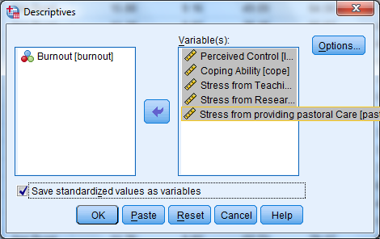

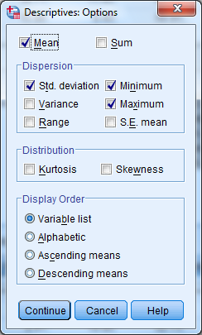

|  |  |  |  |  |  |  |  |
| --- | --- | --- | --- | --- | --- | --- | --- |
| **Descriptive Statistics** | | | | | | | |
|  | N | Mean | Std. Deviation | Skewness | | Kurtosis | |
| Statistic | Statistic | Statistic | Statistic | Std. Error | Statistic | Std. Error |
| Perceived Control | 467 | 17.9002 | 11.92856 | 2.230 | .113 | 7.535 | .225 |
| Coping Ability | 467 | 23.9191 | 15.72082 | 1.465 | .113 | 2.332 | .225 |
| Stress from Teaching | 467 | 55.4253 | 12.81964 | .527 | .113 | .724 | .225 |
| Stress from Research | 467 | 61.9067 | 14.73870 | .005 | .113 | -.405 | .225 |
| Stress from providing pastoral Care | 467 | 55.2463 | 13.47594 | .306 | .113 | .179 | .225 |
| Valid N (listwise) | 467 |  |  |  |  |  |  |